**CHAPTER 1**

**INRODUCTION**

* 1. **Overview**

The project undertakes a multifaceted exploration into error-related potentials (ErrP) utilizing electroencephalography (EEG) across various tasks and participant groups. Its overarching goal is to gain a comprehensive understanding of the neural mechanisms that underlie error processing and cognitive control. By conducting experiments across diverse contexts such as typing tasks, human-robot interaction (HRI), brain-computer interface (BCI) speller tasks, and interactions with humanoid robots, the project seeks to elucidate how the brain responds to errors and adapts behavior in real-time.In the typing tasks, participants are engaged in activities where they type sentences, and their EEG signals are recorded simultaneously. These tasks aim to capture neural responses associated with error perception during typing, providing insights into how the brain processes errors in a controlled setting. By analyzing EEG data, the project endeavors to decode neural signals linked to error monitoring processes, facilitating adaptive behavior and real-time feedback. Sophisticated signal processing techniques, including machine learning algorithms, are employed to classify ErrP signals and provide immediate feedback for adaptive behavior.

Similarly, in the HRI experiments, participants interact with humanoid robots in simplified tasks while their brain activity is recorded using EEG. This setup allows researchers to capture brain activity time-locked to robot actions and analyze neural responses to errors induced by the robot. By visualizing average ErrP signals and highlighting differences between correct and error trials, the project aims to understand how neural responses inform adaptive behavior during human-robot interactions. The findings from these experiments hold significance for improving human-robot interaction by enabling robots to adjust behaviors based on neural responses, ultimately enhancing the efficiency and reliability of the interaction process.Furthermore, the project extends its investigations to BCI speller tasks, where participants engage in tasks involving the detection of spelling errors using brain-computer interface systems. EEG signals are acquired during interactions with the BCI speller, and sophisticated signal processing techniques are employed to extract relevant neural signals and analyze error-related potentials. By understanding neural responses to errors in the context of BCI systems, the project aims to enhance the design and functionality of assistive technologies for individuals with motor disabilities or communication disorders.

Moreover, the project compares ErrP patterns between different participant groups, including healthy individuals, those diagnosed with schizophrenia, and subjects with learning disabilities. By analyzing EEG signals recorded during error monitoring tasks, the project seeks to identify aberrant neural responses associated with cognitive impairments in these populations. Notably, individuals with schizophrenia exhibit distinct neural responses during error monitoring tasks, characterized by heightened negative suppression compared to healthy controls. This abnormal neural response pattern underscores underlying neurobiological dysregulation in schizophrenia and may contribute to cognitive deficits and altered error processing mechanisms in the disorder.Similarly, individuals with learning disabilities show amplified neural responses associated with error detection processes, suggesting intensified neural activity involved in error monitoring and processing among this population. By understanding these neural response patterns, the project aims to develop targeted interventions and treatments for cognitive dysfunction in individuals with diverse cognitive profiles.

This project represents a comprehensive effort to unravel the complex neural processes involved in error perception and cognitive control. Through experiments across various contexts and participant groups, the project aims to decode neural signals linked to error monitoring processes, facilitate adaptive behavior, and inform the development of targeted interventions and treatments for cognitive dysfunction. The findings have implications for improving human-robot interaction, developing assistive technologies, and enhancing the quality of life for individuals with diverse cognitive profiles.

* 1. **Motive of Project**

The primary motive of this project is to delve into the intricate neural processes underlying error detection and cognitive control through the investigation of Error-related Potentials (ErrP) across diverse populations. By analyzing ErrP patterns in healthy individuals, individuals with schizophrenia, and subjects with learning disabilities, we aim to uncover the neural mechanisms involved in error processing and cognitive impairments.

1. **Understanding Neural Responses in Schizophrenia:** One key objective is to elucidate the abnormal neural responses associated with error monitoring tasks in individuals diagnosed with schizophrenia. By comparing ErrP signals between healthy controls and individuals with schizophrenia, we seek to uncover underlying neurobiological dysregulation contributing to cognitive deficits observed in this population.
2. **Exploring ErrP Patterns in Learning Disabilities:** Another objective is to investigate ErrP acquisition in subjects with learning disabilities. By examining ErrP patterns in this population, we aim to gain insights into amplified neural responses associated with error detection processes, thereby enhancing our understanding of cognitive processing mechanisms in individuals with learning disabilities.
3. **Informing Targeted Interventions and Treatments:** Through this project, we aim to inform the development of targeted interventions and treatments for conditions affecting cognitive processing and error monitoring. By understanding the neural mechanisms underlying error processing, we can develop interventions aimed at improving cognitive control and error monitoring abilities in individuals with schizophrenia and learning disabilities.
4. **Contributing to Cognitive Neuroscience:** Ultimately, this project contributes to advancing our understanding of cognitive neuroscience by investigating the neural mechanisms underlying error processing across diverse populations. By uncovering the neural processes involved in error detection and cognitive control, we pave the way for future research aimed at developing more effective interventions and treatments for cognitive impairments.
   1. **Objectives**

The project aims to investigate error-related potentials (ErrP) using EEG across various tasks and groups, focusing on individuals with learning disabilities. By analyzing EEG during typing, human-robot interaction, and BCI tasks, it seeks to understand error perception and cognitive control mechanisms. Additionally, it compares ErrP patterns among healthy individuals, those with schizophrenia, and those with learning disabilities, aiming to identify unique neural responses in the latter group. This research sheds light on challenges in error monitoring and cognition among individuals with learning disabilities, informing the development of interventions to enhance their cognitive processing and error monitoring abilities.

**CHAPTER 3**

**MATERIALS AND COMPONENTS**

**3.1 System Components**

3.1.1 BioAmp EXG Pill

The BioAmp EXG Pill represents a groundbreaking innovation in biotechnology, offering a unique pill-sized chip capable of recording publication-grade biopotential signals directly from the body. With unparalleled versatility, it captures signals from various physiological sources, including the heart (ECG), brain (EEG), eyes (EOG), and muscles (EMG). This cutting-edge technology finds extensive applications in projects within the domains of Human-Computer Interface (HCI) and Brain-Computer Interface (BCI). Its compact size and exceptional signal fidelity make it an invaluable tool for researchers, clinicians, and developers seeking to unlock new frontiers in human-machine interaction and neural interface technologies. The BioAmp EXG Pill sets a new standard in wearable biopotential recording devices, offering unmatched convenience, accuracy, and performance in a compact form factor.

3.1.2 Electrodes

Boxy Gel Electrodes, the compact solution for recording biopotential signals with ease. Measuring just 4.0 x 3.3 x 0.1 cm, these rectangular electrodes feature a conductive solid hydrogel and stainless steel snap connectors for efficient signal transmission. Crafted from polyethylene foam and acrylic medical-grade adhesive, they offer ultra-low impedance (<100 ohms) for rapid baseline stabilization. With lift tabs for convenient placement and removal, these electrodes ensure minimal cleanup thanks to the Ag/AgCl adhesive solid gel. Their special formulation guarantees optimal interface between the body and BioAmp cable, enabling seamless recording of signals from the heart (ECG), brain (EEG), muscles (EMG), or eyes (EOG).

3.1.3 Arduino UNO

The Arduino Uno is a popular microcontroller board based on the ATmega328P chip. It is a part of the Arduino open-source electronics platform, designed for easy prototyping and development of interactive projects. The Uno board features digital input/output pins (both PWM and standard), analog inputs, USB connectivity, a 16 MHz crystal oscillator, a power jack, and an ICSP header.

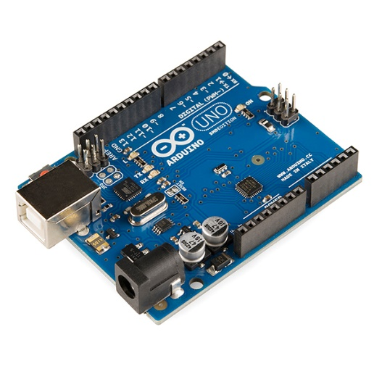

It can be powered either via USB connection or an external power supply. The Uno is programmed using the Arduino Software (IDE), which is user-friendly and supports a simplified version of C++ programming language. With its versatility and wide range of compatible sensors and shields, the Arduino Uno is widely used in various applications such as robotics, home automation, IoT (Internet of Things), and educational projects.

**CHAPTER 4**

**SYSTEM ARCHITECTURE**

* 1. **Circuit Diagram**

EEG circuits, like the one depicted in a schematic diagram, amplify the tiny electrical signals produced by brain activity. These weak signals are picked up by electrodes placed on the scalp and fed into the circuit. The circuit amplifies the signal and filters out noise before sending it to a device like an Arduino for processing and recording. While this offers a basic overview, building a safe and effective EEG system requires specialized medical-grade equipment and expertise due to the sensitivity of the measurements and potential safety risks.

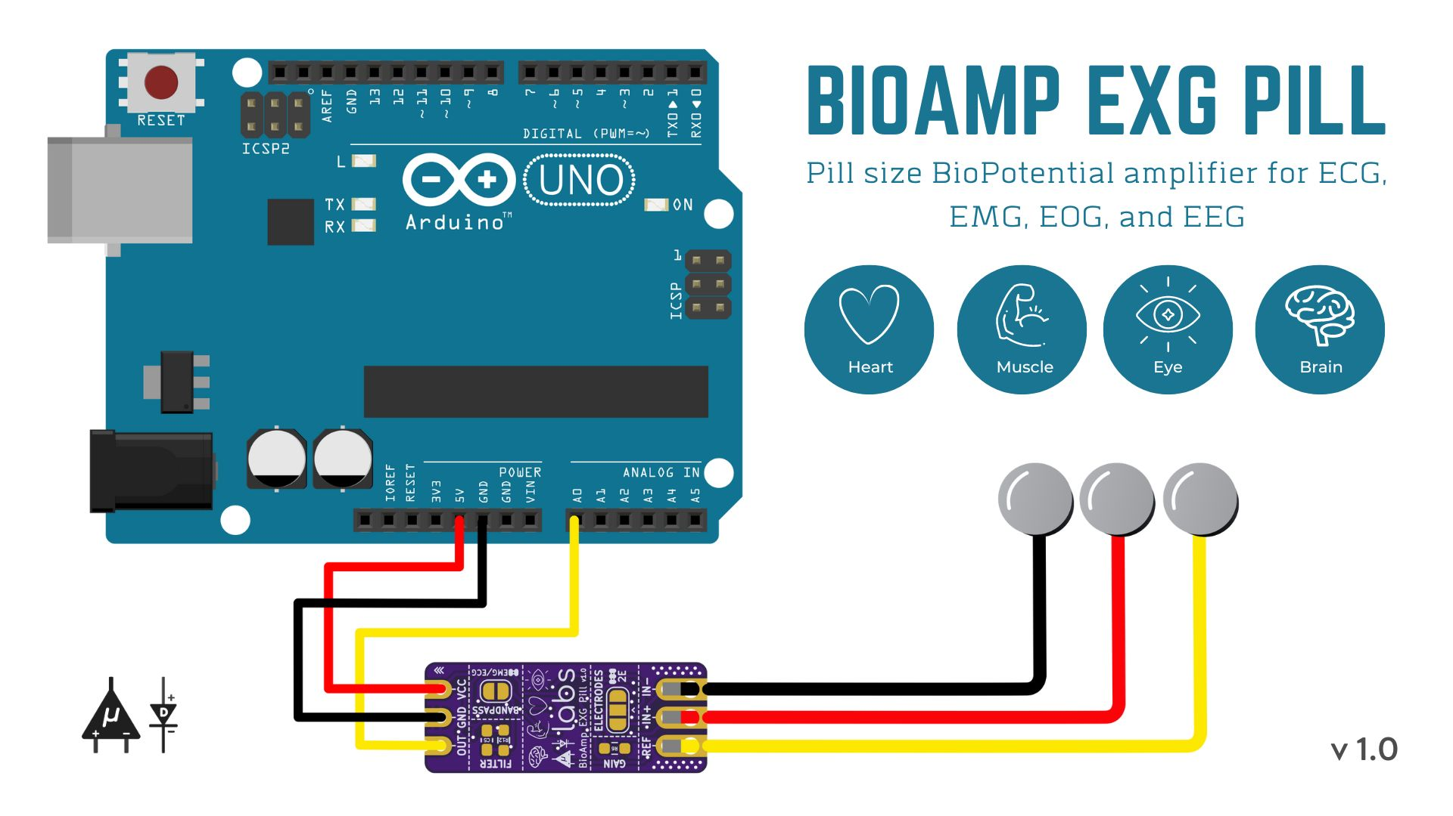

* 1. **Block Diagram**

The block diagram of ErrP Detection system is given below:

1. Signal Acquisition:

Electroencephalography (EEG) signal acquisition involves placing electrodes on specific areas of the scalp, guided by the international 10-20 system. These electrodes capture electrical activity generated by neurons in the brain's frontal, central, and parietal lobes. EEG signals provide valuable insights into various cognitive processes. Proper electrode placement and signal acquisition techniques are crucial to ensure accurate representation of brain activity.

1. Signal Processing:

Once EEG signals are acquired, signal processing techniques are applied to refine the data. This includes eliminating noise and inconsistencies that may obscure the underlying brain activity. Filtering methods such as high-pass, low-pass, band-pass, and notch filters are used to remove unwanted frequency components. Downsampling techniques may be employed to reduce the sampling rate while preserving essential information. Additionally, outlier detection and removal methods help to identify and discard anomalous data points, ensuring the integrity of the analysis.

1. Feature Extraction:

Feature extraction is a critical step in EEG signal processing, where distinct characteristics of the signals are identified. These features may include spectral features like power spectral density, temporal features such as amplitude and frequency of oscillations, or spatial features like coherence between electrode locations. Feature extraction reduces the dimensionality of the data while retaining relevant information necessary for subsequent analysis.

1. Pattern Recognition:

In pattern recognition, the extracted features are utilized to identify patterns or signatures in the EEG signals. For instance, researchers may seek to identify specific patterns of brain activity associated with stimuli presentation or cognitive events. Machine learning algorithms such as support vector machines, neural networks, or Bayesian classifiers are commonly employed for pattern recognition tasks, aiding in the understanding of cognitive processes and neurological disorders.

1. Visualization:

The final step involves visually presenting the processed EEG signals for analysis and interpretation. Visualization techniques such as time-domain plots, frequency-domain plots (e.g., spectrograms), topographic maps, and event-related potential (ERP) plots facilitate the exploration of temporal dynamics, spatial distributions, and frequency characteristics of the EEG signals. Graphical representation enhances understanding and aids in identifying meaningful insights, contributing to advancements in neuroscience research and clinical applications.

* 1. **Methodologies**

4.3.1 Methodology of the error-detection five eye-gazing experiments

Our study encompassed a series of five eye-gazing experiments designed to investigate the nuances of Error-Related Potentials (ErrPs) observed in EEG signals across diverse experimental conditions and participant demographics. The primary objective was to discern potential variations in ErrP patterns elicited by different stimuli and among individuals, shedding light on the underlying neural mechanisms governing cognitive processing and error detection.

**Participant Recruitment and Characteristics:**

Participants were recruited from the local community through advertisements and word-of-mouth referrals. A diverse sample was sought to ensure variability in demographic characteristics such as age, gender, and educational background. Informed consent was obtained from all participants prior to their involvement in the study. The inclusion criteria encompassed individuals of early 20’s without a history of neurological or psychiatric disorders that could affect EEG signals.

**Experimental Design:**

Each eye-gazing experiment was meticulously designed to manipulate specific gaze behaviors and cognitive processes while recording EEG signal. Stimuli presentation and task instructions varied across experiments to elicit distinct cognitive responses, including error detection and attentional processes.Experimental conditions were randomized to minimize order effects, and counterbalancing techniques were employed to control for potential confounding variables. Each participant completed all five experiments, with short breaks provided between sessions to minimize fatigue and maintain engagement.

**EEG Signal Acquisition Setup:**

EEG signals were recorded using a BioAMP EXG Pill acquisition integrated circuit (IC) specifically designed for EEG signal acquisition, connected to an micro-controller programmed with custom scripts for data acquisition and processing. Two electrodes were positioned at the frontal-central region of the participant's scalp according to the standard 10-20 electrode placement system, while the third electrode served as the reference electrode. Electrode impedance was maintained below 5 kΩ to ensure optimal signal quality. The hardware setup was complemented by a Mixed Storage Oscilloscope (MSO) with 1Gs/s for real-time visualization of the recorded EEG signals, allowing for immediate feedback during data collection.

**Experimental Procedure:**

Participants were comfortably seated in a dimly lit room, with the experimental setup explained to them before commencement. They were instructed to maintain a relaxed but attentive state throughout the experiment and to minimize head and body movements to prevent artifact contamination in the EEG signals. Each experiment consisted of multiple trials, with participants instructed to fixate their gaze on a central stimulus while responding to task-specific cues or prompts presented on a computer monitor. EEG signals were continuously recorded during the experiment, with trials lasting between 3 to 5 minutes each to capture a sufficient number of epochs for subsequent analysis.

**Data Analysis:**

Recorded EEG signals were perprocessed to remove noise and artifacts using standard techniques, including filtering, artifact rejection, and baseline correction. Epochs corresponding to specific experimental conditions were extracted from the preprocessed EEG data for further analysis[45]. Time-domain and frequency-domain features were computed from the EEG epochs to characterize the neural responses associated with error processing and attentional modulation[46]. Statistical analyses, including repeated measures ANOVA and correlation analyses, were performed to examine the effects of experimental manipulations and individual differences on ErrP amplitude and latency.

**Graphical Output and Interpretation:**

The graphical outputs obtained from each experiment depicted the temporal dynamics of ErrPs across different experimental conditions and participant groups[30]. Visual inspection of the ErrP waveforms revealed distinct patterns of neural activity associated with error detection and cognitive processing. Quantitative analysis of the graphical data allowed for the identification of significant differences in ErrP characteristics between experimental conditions and among participants. These findings provided valuable insights into the neural mechanisms underlying error monitoring and attentional processing, highlighting the complex interplay between cognitive processes and neural activity.

Methodology involved a comprehensive approach to investigate Error-Related Potentials (ErrPs) in EEG signals through a series of eye-gazing experiments. By manipulating experimental conditions and participant demographics, we aimed to elucidate the intricacies of neural responses associated with error processing and attentional modulation. The utilization of advanced EEG signal acquisition techniques, coupled with meticulous experimental design and data analysis, enabled us to uncover subtle variations in ErrP patterns and their implications for cognitive neuroscience research. Through this methodology, we contribute to the growing body of literature on error monitoring and cognitive control, paving the way for future studies to further elucidate the underlying mechanisms of cognitive processing

**CHAPTER 5**

**RESULT AND DISCUSSION**

In the study, an investigation into Error-related Potentials (ErrP) was conducted using data from various sources. Firstly, healthy individuals were tasked with plotting ErrP graphs alongside corrected graphs, providing valuable insights into the typical response patterns of this neural phenomenon. Additionally, ErrP signals were obtained from a dataset comprising individuals diagnosed with schizophrenia, allowing for comparative analysis between healthy and clinically affected populations. Moreover, the research extended to include real-time ErrP signals from a cohort of 16 subjects with learning disabilities, aiming to broaden understanding of ErrP across diverse cognitive profiles. The results derived from these datasets are poised to offer significant contributions to the field, potentially shedding light on the underlying neural mechanisms of error processing in both healthy and clinical populations, thereby paving the way for more targeted interventions and treatments for conditions affecting cognitive processing and error monitoring.

**5.1 Analyzing ErrP Patterns in Healthy Patients**

The four tasks described involve investigating error-related potentials (ErrPs) in various contexts: typing tasks, human-robot interaction (HRI), and brain-computer interface (BCI) speller tasks. By analyzing EEG signals, these tasks aim to understand neural responses associated with error perception, facilitating adaptive behavior and real-time feedback. The ErrP graph plots, depicting average brain activity waveforms for correct and error trials, highlight variations in neural responses. These tasks hold significance for improving human-robot interaction and developing more intuitive BCI systems.

ErrP pattern recognition is crucial for decoding neural signals and informing adaptive behavior in real-world applications. Importantly, these tasks can be applied to healthy patients to study cognitive processes, enhance human-computer interaction, and develop assistive technologies for individuals with motor disabilities or communication disorders, ultimately improving quality of life.

Fig1.Errp pattern Recognition by using Gaze based keyboard task.

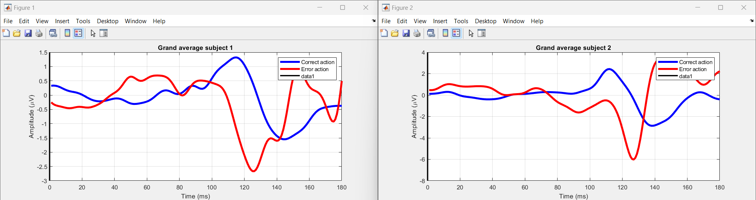

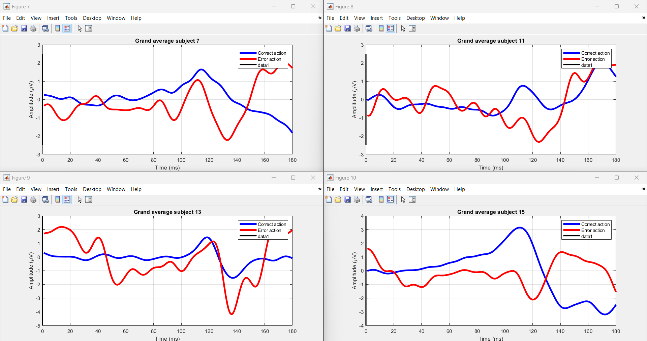

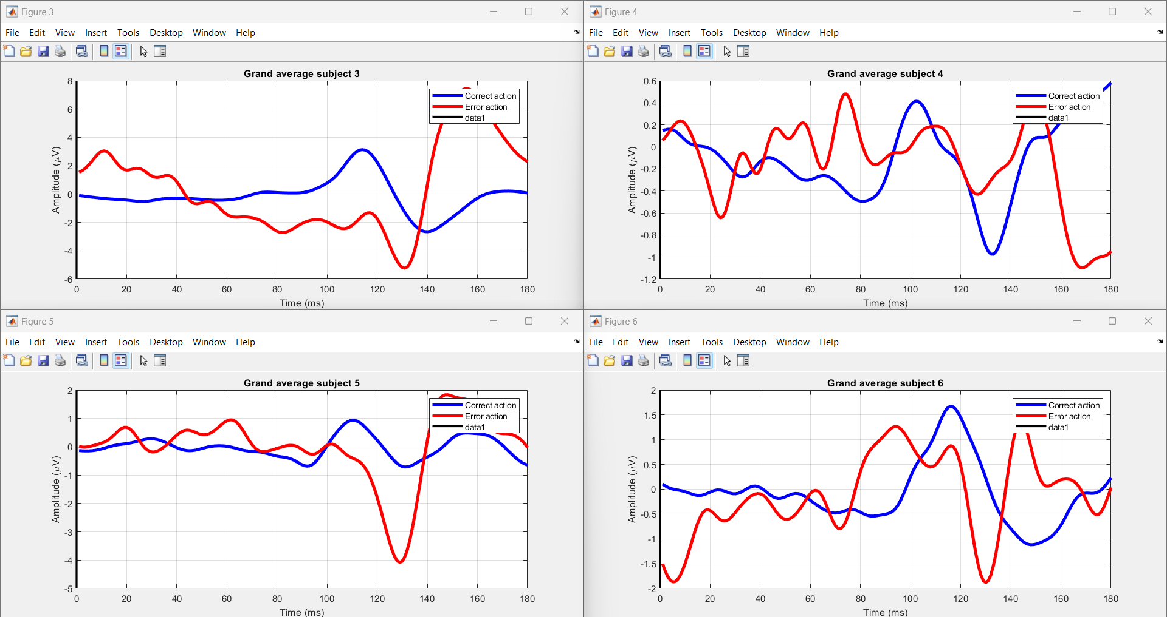

The task at hand involves investigating the physiological responses associated with error perception during typing tasks(The graph will superimpose the average brain activity waveforms for both correct and error trials, accentuating variations in neural responses between the two). Each session comprises typing a sentence followed by a brief pause. Data encompassing typing speed, accuracy, and error detection are collected. The EBNeuro EEG device records brain electrical activity using 64 wet electrodes, while the SMI myGaze eye-tracker captures gaze movements on the screen. The Lab Streaming Layer software synchronizes EEG and eye-tracking data streams for coherent analysis. Segmented into epochs, data epochs capture physiological responses around key presses. Support Vector Machine (SVM) models are employed for classifying correct and erroneous typesetting based on collected data. The process involves data loading, preprocessing, feature extraction, dataset splitting, and training SVM models. Code functionalities include loading EEG data, visualizing EEG activity for each subject, and saving processed data into MAT files for further analysis. The study involves 10 participants, aiming to understand the interplay between physiological responses and error perception during typing tasks.

Fig 2.Errp pattern Recognition by using Human-Robot Interaction.

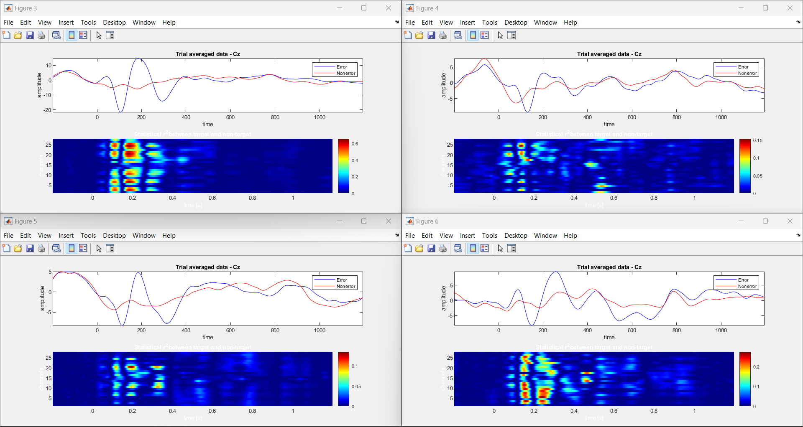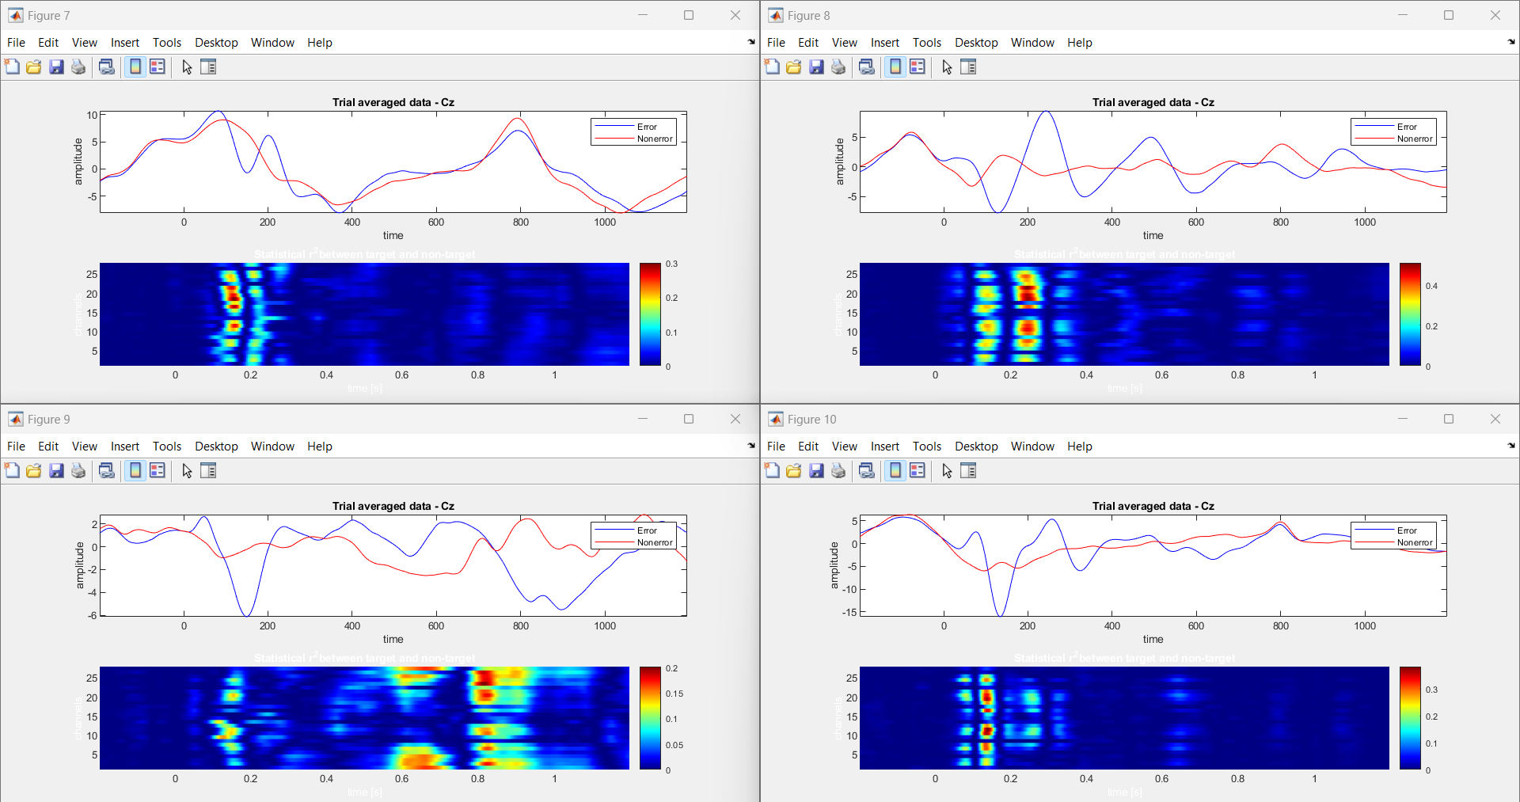

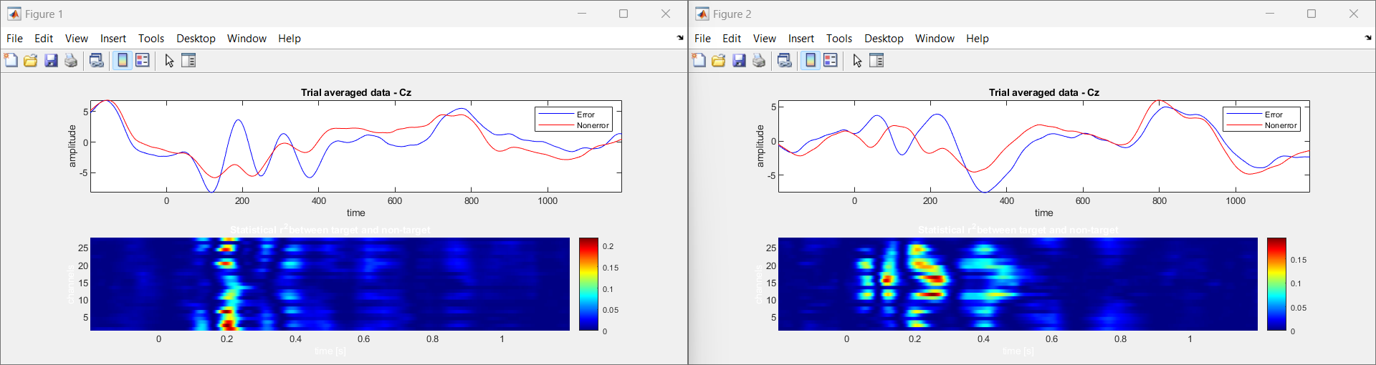

The Human-Robot Interaction (HRI) investigates EEG-based ErrPs (error-related potentials) during interactions with a humanoid robot in a simplified task. Using an ActiCHamp amplifier with electrodes, the study captures brain activity time-locked to robot actions. Advanced signal processing and high-quality signal acquisition ensure accurate data collection. MATLAB and EEGLAB are employed for preprocessing, including common average reference application and band-pass filtering. Epoching and event selection focus analysis on relevant feedback presentation instances. Support Vector Machine (SVM) classification is utilized for error detection. The project emphasizes visualizing average ErrP signals, highlighting differences between correct and error trials. This enables understanding of neural responses to robot-induced errors, facilitating adaptive behavior and real-time feedback. By decoding EEG signals, the study informs the robot's actions, enhancing its interaction capabilities. The study findings hold significance for improving human-robot interaction by enabling robots to adjust behaviors based on neural responses.

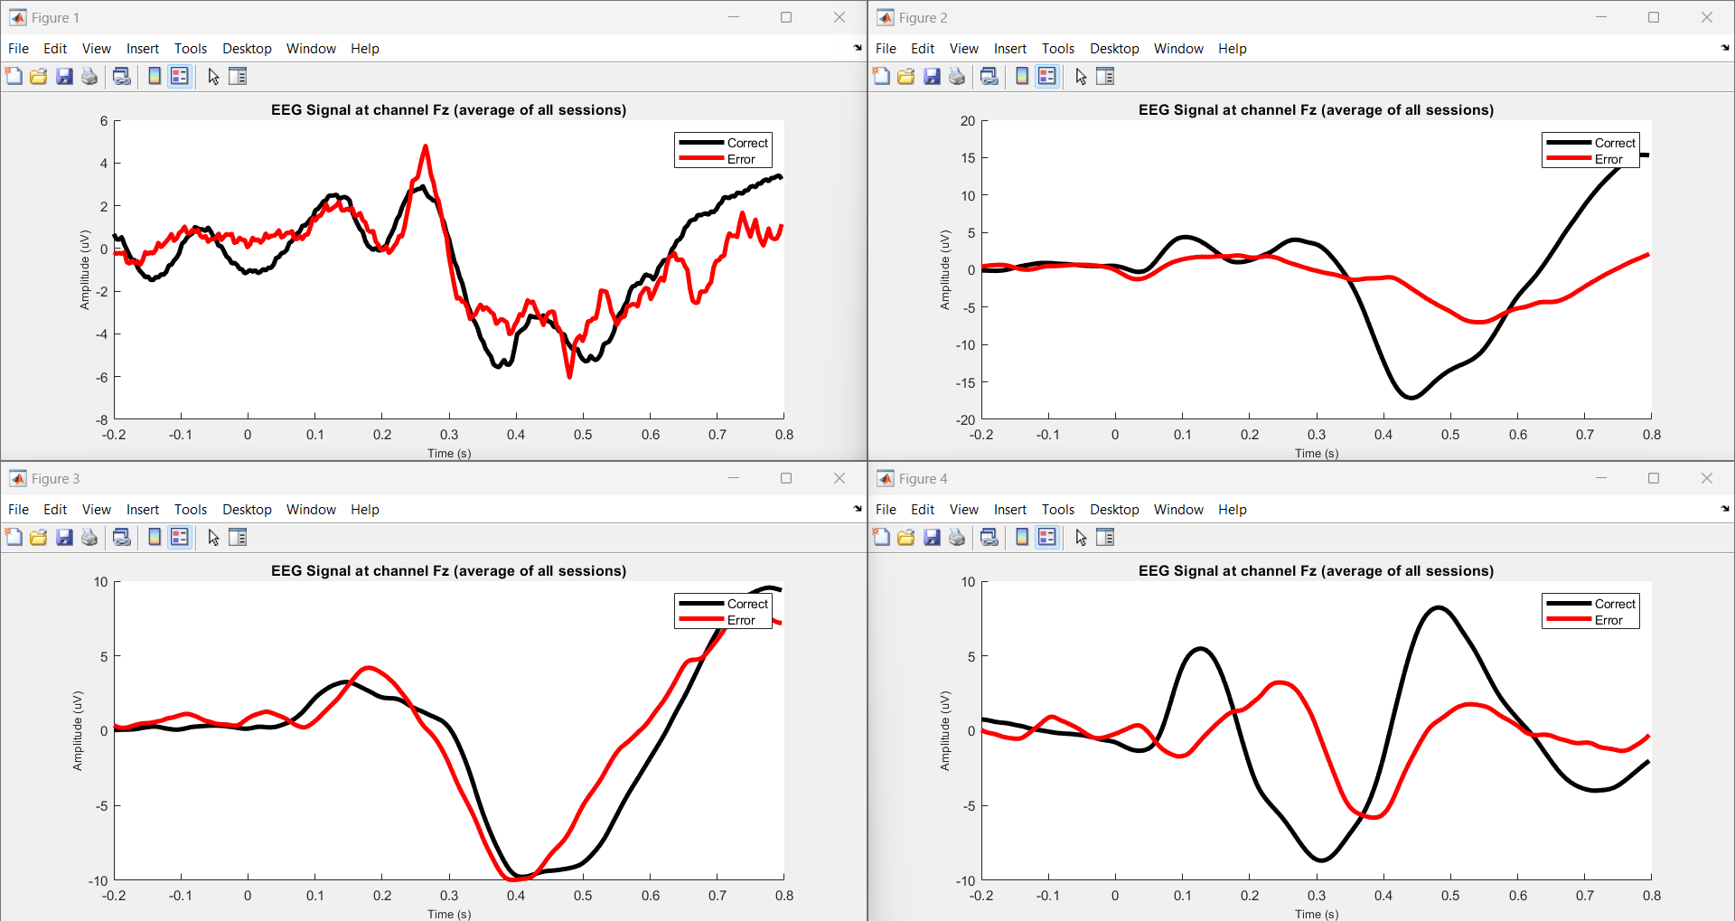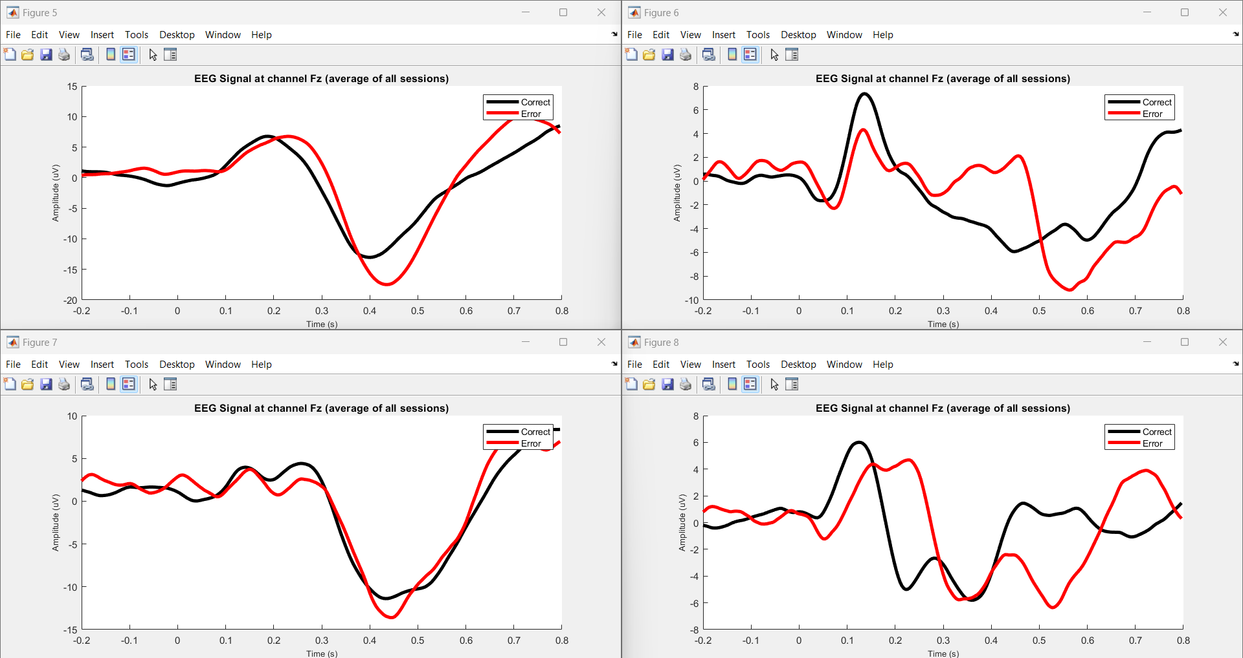

Fig 3.Errp pattern Recognition by using P300 based BCI speller.

The task investigates error-related potentials (ErrPs) and P300 event-related potentials (ERPs) in EEG data, particularly focusing on human-robot interaction (HRI). EEG signals are acquired using an ActiCHamp amplifier, capturing brain activity during interactions with a humanoid robot in a simplified task. Preprocessing involves filtering EEG data to extract relevant neural signals, followed by ErrP data extraction and labeling. The processed data, including participant IDs and session information, are stored for analysis. The project utilizes MATLAB for data processing and visualization, including plotting average EEG signals at channel Fz for correct and error conditions. This analysis aids in understanding neural responses to robot-induced errors, facilitating adaptive behavior and real-time feedback. The task aims to improve human-robot interaction by enabling robots to adjust behaviors based on neural responses, enhancing the efficiency and reliability of the interaction process.

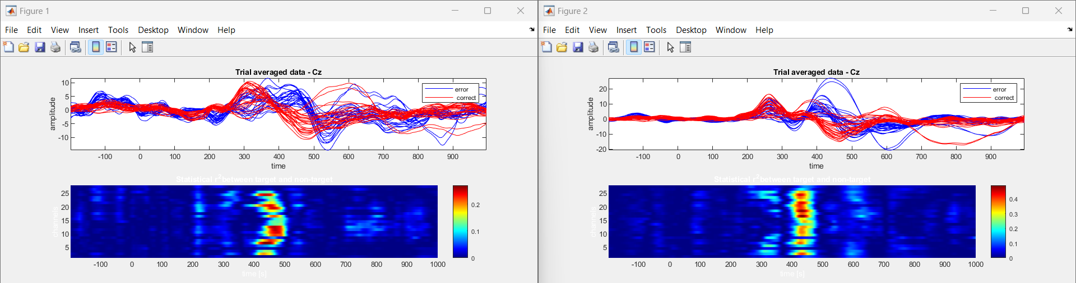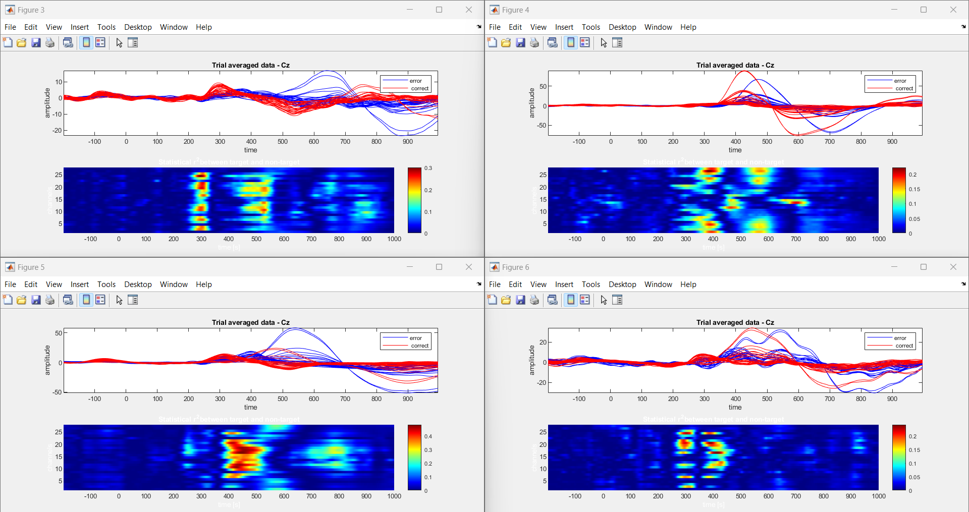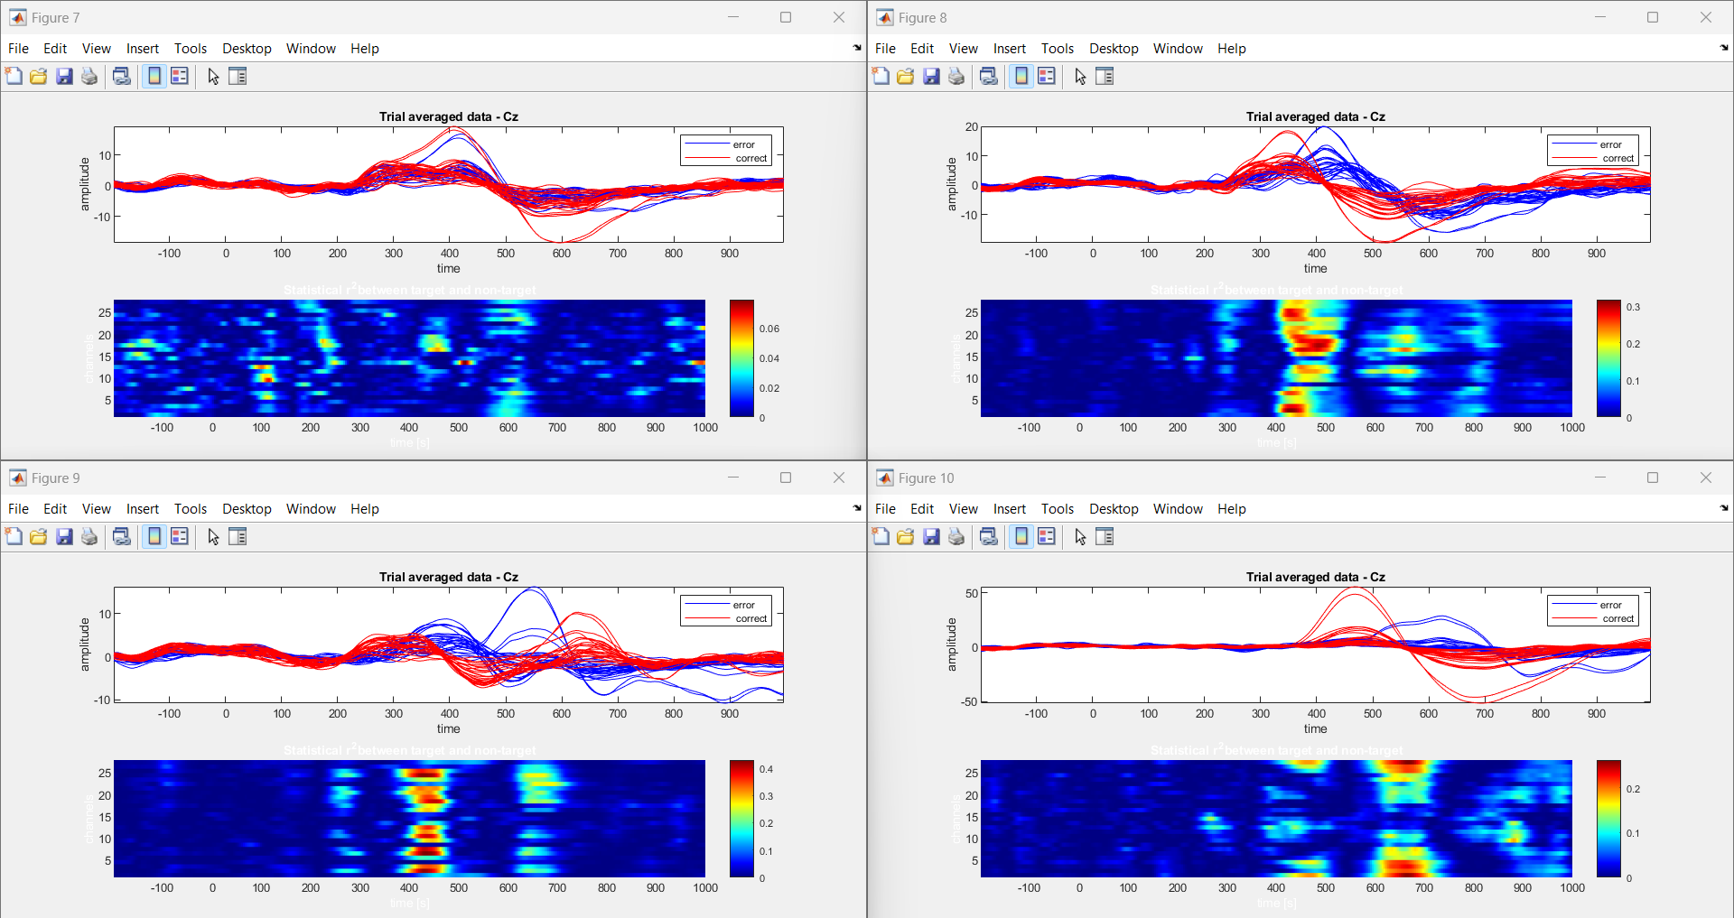

Fig 4. Errp pattern Recognition by using Human-Robot interaction task (Fostering Human-Agent Co-Adaptation Through Error-Related Potentials)

In "Human-agent Co-adaptation using Error-related Potentials", participants engaged in a guessing game with a robot partner. EEG data was acquired during two main phases: a calibration session and closed-loop co-adaptation sessions. The calibration session involved participants guessing the robot's chosen object, while closed-loop sessions continued this interaction. EEG signals were analyzed to decode error-related potentials (ErrPs), indicative of participant's error perception. The robot's behavior adapted based on these decoded ErrPs, fostering human-agent co-adaptation. Data analysis involved preprocessing EEG signals, extracting features, and decoding ErrPs for real-time feedback. Graphical analysis of ErrPs provided insights into participants' error perception dynamics, facilitating adaptive behavior in the robot. Overall, the task aimed to enhance human-agent collaboration through real-time neural signal processing, paving the way for more intuitive and efficient human-robot interaction paradigms.

**5.2 EEG ErrP Dataset Comparison between Schizophrenia and Healthy Controls**

In our study, we conducted analyses comparing EEG signals during a button-tone task between individuals diagnosed with schizophrenia and healthy controls. The preprocessing of EEG data ensured data quality by removing artifacts. Subsequently, we plotted the EEG signals recorded during the task for both groups using Python.Our analysis aimed to gain insights into the neural mechanisms underlying schizophrenia and potential differences in task performance between the two groups. Notably, individuals with schizophrenia may experience predictive coding failures, leading to inappropriate salience of sensations that should have been predicted but were not. These failures in predictive mechanisms can influence the suppression of neural responses, including the reduced suppression of the negative peak observed in individuals with schizophrenia.

Moreover, cognitive impairments such as deficits in attention, working memory, and executive functions may further impact the suppression of neural responses in individuals with schizophrenia. Dysfunctional cognitive processes may disrupt the regulation of neural activity, contributing to variations in suppression levels, including the reduced suppression of the negative peak in ERPs observed in schizophrenia compared to healthy controls. The interplay between cognitive impairments, neural processing abnormalities, and predictive coding failures collectively influences the suppression of neural responses, such as the negative peak observed in EEG ERPs. Differences in cognitive functioning and neural mechanisms between healthy controls and individuals with schizophrenia may underlie the observed differences in suppression levels, reflecting the complex interplay of cognitive and neural factors in the disorder.

Overall, our analysis of EEG ErrP datasets highlights the intricate relationship between cognitive impairments, neural processing abnormalities, and predictive coding failures in schizophrenia. These findings contribute to a deeper understanding of the disorder's neurobiology and may inform future research directions and treatment approaches aimed at addressing cognitive and neural dysfunctions in schizophrenia.

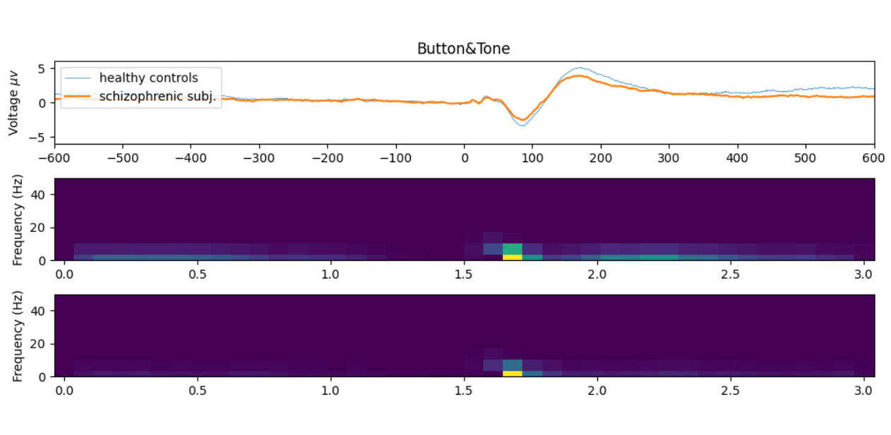

Table 1. Comparison of ErrP features between HC and SZ .

|  |  |  |
| --- | --- | --- |
| Feature | Healthy Subjects(HC) | Schizophrenia(SZ) |
| ERP activation strength | Strong | Fainter |
| Time-domain response | Clearer peaks and valleys | Smoother waveforms, potentially reduced differentiation |
| Spatial distribution | Similar topography across electrodes | Potential differences in electrode activation patterns |
| Short-time fourier transform (STFT) | Distinct frequency bands involved | Overlap with human cognition (HC) in the condition, potentially indicating weaker activation. |
| Population-level differences | More consistent responses within group | Higher variability between individuals |

Furthermore, our analysis revealed that individuals with schizophrenia exhibited greater negative suppression compared to healthy controls, as depicted in the graph. This indicates abnormal neural response patterns in schizophrenia, particularly in error monitoring tasks. The heightened negative suppression observed suggests underlying neurobiological dysregulation contributing to cognitive deficits and altered error processing mechanisms in the disorder. These findings underscore the significance of understanding these mechanisms for improving diagnostic and therapeutic strategies for schizophrenia.

**5.3 Error-related Potentials (ErrP) Acquisition in Subjects with Learning Disabilities**

In this study, EEG techniques captured real-time neural activity associated with Error-related Potentials (ErrP). Three electrodes placed strategically on participants' frontal-central scalps recorded neural signals linked to error monitoring. Graphical representations and CSV files enabled detailed analysis, offering insights into cognitive processing in real-time. Differences in ErrP patterns between conditions and participant groups were observed, highlighting the interplay between cognitive processes and neural activity. This approach contributes to understanding error monitoring mechanisms and cognitive control, with implications for targeted interventions in various populations.

The research investigated how our brains handle errors using a technique called electroencephalography (EEG). Participants engaged in eye-gazing experiments with varying conditions. Researchers monitored their brain activity through EEG, specifically focusing on error-related potentials (ErrPs). These ErrPs are tiny voltage fluctuations that occur when the brain detects an error. By analyzing the timing and characteristics of these ErrPs across different conditions and participants, the researchers aimed to understand how attention, error processing, and brain activity interact. The findings provide valuable insights into the complex interplay between our thoughts and brain functions, furthering our understanding of cognitive neuroscience.

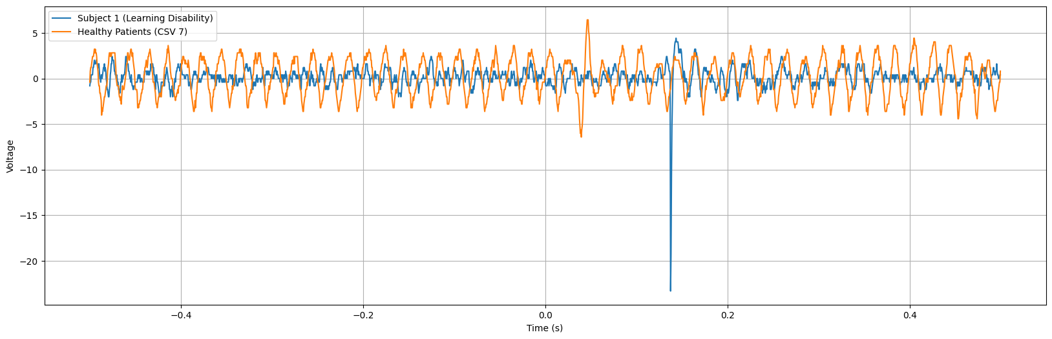

The graph depicts Error-related Potentials (ErrP) of subjects with learning disabilities, showcasing a notably higher negative peak occurring around 170 ms after error onset. This heightened negative peak suggests an amplified neural response associated with error detection processes in individuals with learning disabilities. The increased magnitude of the negative peak may reflect intensified neural activity involved in error monitoring and processing among this population.

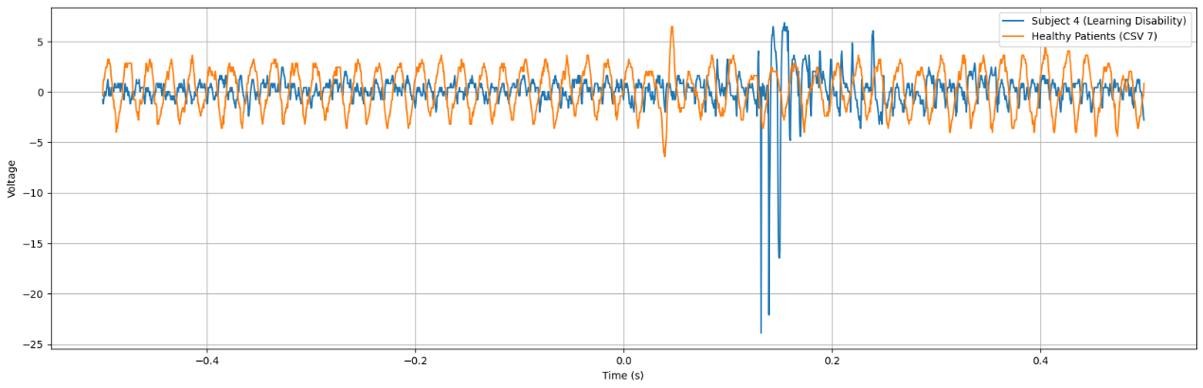

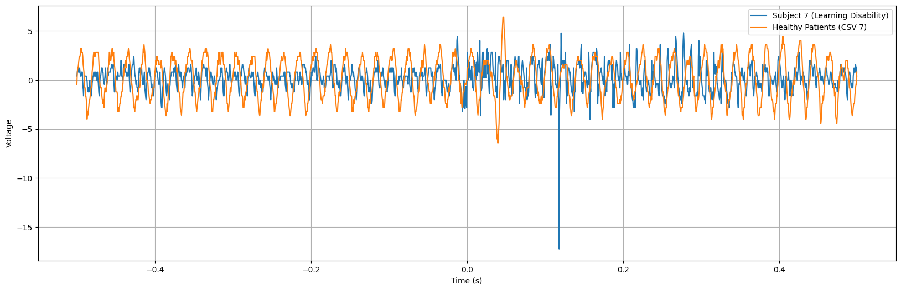

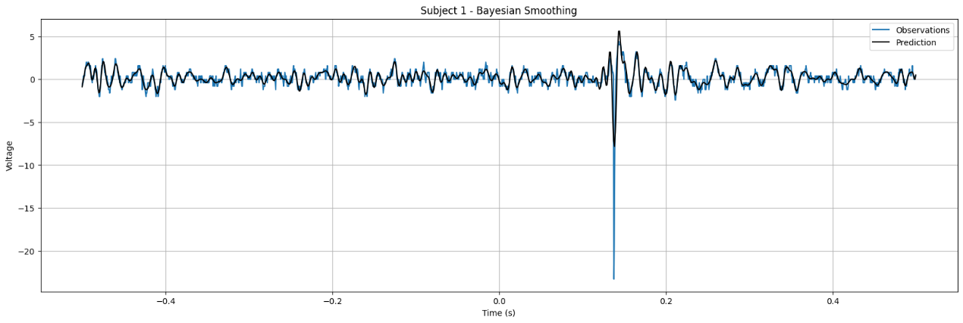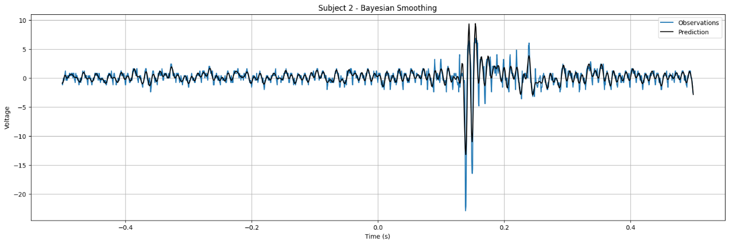

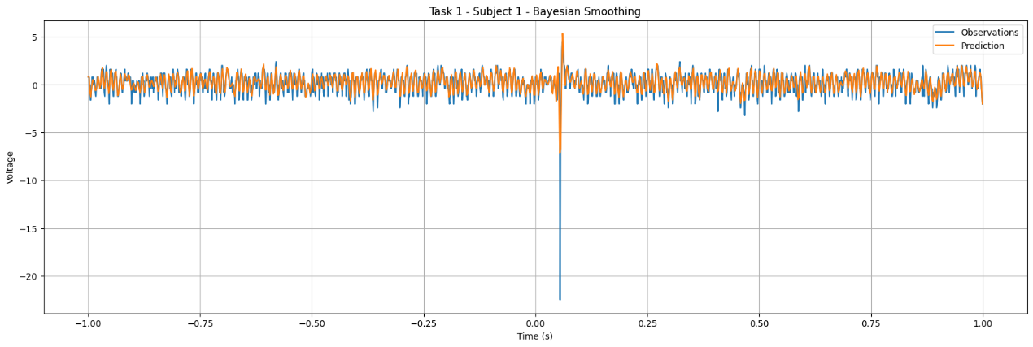

**5.4 Discussion**

The investigation into Error-related Potentials (ErrP) across various contexts and populations has provided valuable insights into the neural mechanisms underlying error processing and cognitive control. These findings have important implications for understanding cognitive impairments in conditions such as schizophrenia and learning disabilities, as well as for developing targeted interventions and treatments.

1. **Schizophrenia and Abnormal Neural Responses:** The comparison between individuals with schizophrenia and healthy controls revealed distinct neural response patterns during error monitoring tasks. Specifically, individuals with schizophrenia exhibited heightened negative suppression, indicating underlying neurobiological dysregulation. This abnormal neural response pattern may contribute to cognitive deficits observed in schizophrenia, such as deficits in attention, working memory, and executive functions. Understanding these neural mechanisms is crucial for developing targeted interventions to improve cognitive processing and error monitoring in individuals with schizophrenia.
2. **Learning Disabilities and Amplified Neural Responses:** The investigation into ErrP acquisition in subjects with learning disabilities uncovered amplified neural responses associated with error detection processes. This heightened negative peak suggests intensified neural activity involved in error monitoring and processing among individuals with learning disabilities. These findings highlight the importance of understanding cognitive processing mechanisms in diverse populations and developing tailored interventions to improve cognitive processing and error monitoring in individuals with learning disabilities.
3. **Implications for Intervention and Treatment:** The insights gained from ErrP research have significant implications for developing targeted interventions and treatments for conditions affecting cognitive processing and error monitoring. By understanding the neural mechanisms underlying error processing, researchers and clinicians can develop interventions aimed at improving cognitive control and error monitoring abilities in individuals with schizophrenia and learning disabilities. These interventions may include cognitive training programs, neurofeedback techniques, or pharmacological interventions targeting specific neural pathways implicated in error processing.
4. **Future Directions:** Future research in ErrP could focus on further elucidating the neural mechanisms underlying error processing across different populations and contexts. Additionally, longitudinal studies could investigate how neural response patterns change over time and in response to interventions. Furthermore, integrating neuroimaging techniques such as functional magnetic resonance imaging (fMRI) or magnetoencephalography (MEG) with EEG could provide a more comprehensive understanding of the neural circuits involved in error processing.

**CHAPTER 6**

**CONCLUSION**

Based on the investigations into Error-related Potentials (ErrP) across various contexts and populations, significant insights into neural processing associated with error detection and cognitive control have been gleaned. From analyzing EEG patterns in healthy patients to comparing ErrP signals between individuals with schizophrenia and healthy controls, as well as examining ErrP acquisition in subjects with learning disabilities, a comprehensive understanding of the neural mechanisms underlying error processing has been achieved.The findings suggest that individuals with schizophrenia exhibit distinct neural responses during error monitoring tasks, characterized by heightened negative suppression compared to healthy controls. This abnormal neural response pattern highlights underlying neurobiological dysregulation in schizophrenia, potentially contributing to cognitive deficits and altered error processing mechanisms in the disorder. These insights underscore the importance of understanding the complex interplay between cognitive impairments, neural processing abnormalities, and predictive coding failures in schizophrenia for developing targeted interventions and treatments.

Furthermore, the investigation into ErrP acquisition in subjects with learning disabilities revealed amplified neural responses associated with error detection processes. This heightened negative peak suggests intensified neural activity involved in error monitoring and processing among individuals with learning disabilities. Understanding these neural response patterns offers valuable insights into cognitive processing mechanisms in diverse populations, facilitating the development of targeted interventions to improve cognitive processing and error monitoring in individuals with learning disabilities.